1st Author Name  Affiliation City, Country e-mail address | 2nd Author Name  Affiliation City, Country e-mail address | 3rd Author Name  Affiliation City, Country e-mail address

Introduction
In this assignment, our task is to find various ways that AR could be employed with the aim of improving experiences in museums. Therefore, we conducted field research to examine how museum users currently use the museums and the experiences they have regarding these exhibits. To conduct field research, there are two museums that my friend visited. The two museums are the Royal Air Force Museum and the Horniman museum. My friend is a lover of the museum, and therefore we joined hands to accomplish the research task. However, I cannot use my own experience to examine various ways of improving museum experiences using AR. The basis of my improvements will be my friend who visited the museum frequently and their experiences will help me a lot.

Research
The two museums visited are the Royal Air Force Museum and the Horniman museum. In this field research, we were looking for different approaches that the two museums use in order to display their exhibits. In other words, we were looking at whether the museums display their exhibits traditionally or they use interactive ways to display exhibits which make them more interesting. There is various information that we collected regarding the two museums. The Royal Air Force Museum (RAFM) had employed an interactive way of displaying their exhibits. “However, many of their exhibits still had the traditional information board attached to them which never attracted my friends.” (In Dieck & In Jung, 2019) RAFM has made a huge step in making the museum experience interactive although it is yet to achieve this. On the other hand, the Horniman Museum in displaying their exhibits applies an approach that is more traditional. The use of guide tours is an affirmation of this and a visitor may opt to explore the museum on their own. Each exhibit at Horniman had an information board that educated the visitors about it.
The information collected was analyzed based on interaction. Museum exhibits should be highly interactive so that visitors being much engaged which will improve their experiences. There are various discoveries made in these museums. The research findings include;
- The two museums had long queues visitors getting to use the interactive exhibits.
- There was a lack of interactivity as the two museums mostly use traditional approaches when displaying their exhibits.
- The two museums employed use of text that my friend did not seem to be attracted to them.
The three discoveries influenced our AR design ideas massively. AR would ensure no long queues as visitors will use their smart devices or rent from the museum and get a whole new experience of the museum exhibits. For interactivity and text usage, the AR will superimpose sounds and text on the devices the visitors are using to view the exhibits to bring a reality altered version.

Design Concepts
The design concept of the AR is a 3D one with interactive text displayed on the exhibits. This concept is aimed at reducing large queues as visitors will use the AR to view the exhibitions. “This AR concept will enable visitors to use their tablets or smartphones to see the exhibits come alive and be transported to the reality of the 21st-century.” (In Dieck & In Jung, 2019) This design caters to every visitor including the visual impaired as the experience will be made very suitable. The model will be an immersive installation in three-dimensional animations where visitors will interact with. The picture below shows a visitor interacting with the AR concept. The design will have two primary functions which are to allow the user to view the overlaid information on information boards and on pictures and allowing users to view exhibit models from 3D angles. The use of AR will transmit a3D on the museum exhibits models implying they will have length, width, and height. The T-Rex use will solve the issue of information signs which are hard to read. The Vuforia Object Scanner usage will make it easy to make the exhibits’ 3D model which will be able to import to Unity as a triggered object. The implication of this is that, whenever a device is pointed towards the real model by the user, they can access on the device the model information by simply touching the device screen. The T-Rex in a 3D model will be used for this prototype in order to show how AR will be used in adding the overlaid information. The 3D model of T-Rex is used as the actual museum exhibits representation models. This enables museum visitors to view the exhibits models via their devices and by touching their screen to get the information through written text, video and audio. The visitors will have different choices on how they wish to receive the exhibits information as they can listen, watch video or see written text which is very suitable even for visually impaired and people who are deaf. This is shown in the below mockup images.

Figure 1 below shows the prototype initial which allows overlaid information to be seen using AR. Visitors can view an exhibit and one of a T-Rex video appears wit information.

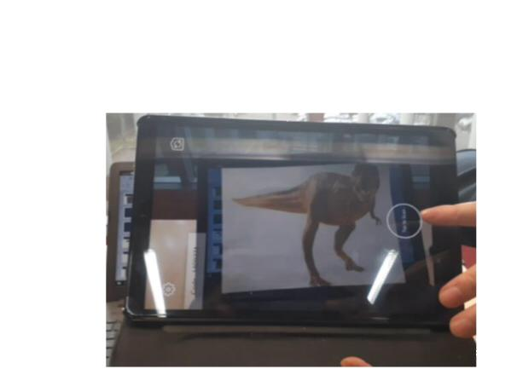

Figure 2 below shows the overlaid video

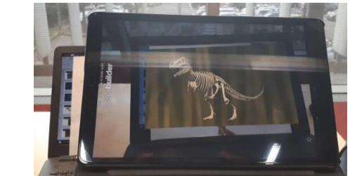

Figure 3 below shows a sketch of the initial idea and shows a T-Rex model in a museumand the view of it through a device with information overlid using AR.

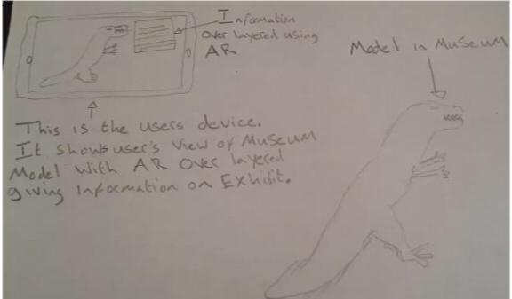

Figure 4 below shows a mockup which a visitor’s devices view. T-Rex model was used to represent museum model and labels are layered on to the model showing the visitors where they can touch to gain more information.

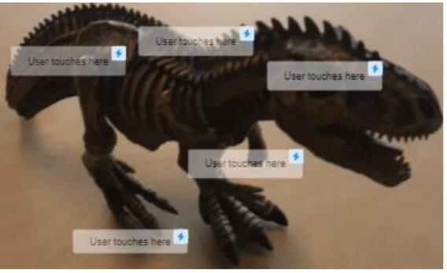

Figure 5 below a mockup which shows the view through the device of the visitor with AR overlayered information

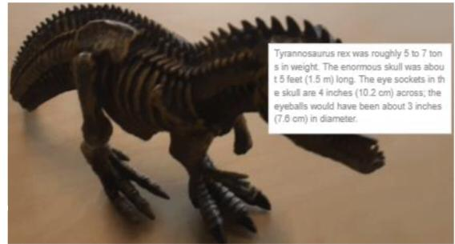

Prototype

In order to turn this AR concept into a running prototype, the concept after being developed in an interactive design process was subjected to a testable set up to evaluate both software and hardware. A basic pilot experiment was also conducted in order to explore what it means about the interactivity of the design concept. “The decision made was that the AR design concept needed some modification.” (In Crawford & In Kane, 2017) The modification was to allow visitors to record their experience at the museum which they can enjoy later in the comfort of their homes.

Team working
The team comprised my friend and I where my friend visited the museums. Teamwork was very critical and work and responsibility were not distributed among team two of us. The team performed work and responsibilities one after the other and thus made us achieve our goal.

Conclusion
Marker-Based AR will be utilized specifically the object tracking 3D. This implies using an augmented reality in order to blend real-objects with virtual reality of the 21st century. The use of 3D tracking of object, all dimensions of the museum models will be considered as a trigger for overlaid information. A point where information can be placed where it can be triggered and displayed is called a trigger. Te 3D objects will be created by the utilized Vuforia Object Scanner and import them to Unity. The use of Unity will aid in placing multiple triggers on the exhibit models.

Figure 6 shows a scan of the T-Rex model which utilized Vuforia Object Scanner

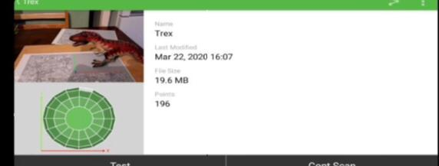

References
In Dieck, M. C., & In Jung, T. (2019). Augmented reality and virtual reality: The power of AR and VR for business.
In Crawford, B. A., & In Kane, E. (2017). The augmented museum: Essays on opportunities and uses of augmented reality in mus

